**Project Name: Addition Made Easy!**

AWS Services: AWS Amplify, API Gateway, Lambda, DynamoDB

Diagramming Tool: Eraser.io

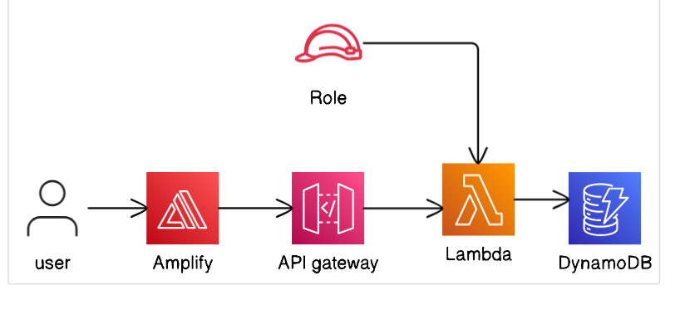

1. DynamoDB
   1. Partition Key: “Name” (String)
   2. Table_Name
   3. ARN of DynamoDB (For permission)
2. Lambda Function
   1. Code Provided
   2. Modify your Table name, Partition Key
3. Permission for Lambda function
   1. Execution Role (created by default)
   2. Least Privilege Permission: Read and Write to DynamoDB (JSON Policy is also provided)
4. API gateway
   1. POST method
   2. API gateway Endpoint (Invoked URL) is provided to API calls
5. AWS Amplify
   1. Used for hosting website: Updating and deploying website is easy with AWS Amplify
   2. Use zipped html file while uploading
   3. index.html file is provided